Name Date

1. The picture below shows $\frac{3}{4}$ of the rectangle shaded. Use the picture to show how to create an equivalent fraction for $\frac{3}{4},$ and then subtract $\frac{1}{3}$.

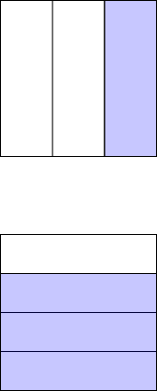 $\frac{3}{4}-\frac{1}{3}=$ $\frac{3}{4}-\frac{1}{3}=$

1

1. Find the difference. Use a rectangular fraction model to find common denominators. Simplify your answer, if possible.
2. b.



1. d.
2. f.

3. Robin used $\frac{1}{4}$ of a pound of butter to make a cake. Before she started, she had $\frac{7}{8}$ of a pound of butter. How much butter did Robin have when she was done baking? Give your answer as a fraction of a pound.

1. Katrina needs $\frac{3}{5}$ kilogram of flour for a recipe. Her mother has $\frac{3}{7}$ kilogram of flour in her pantry. Is this enough flour for the recipe? If not, how much more will she need?