Name Date
- Convert and write an equation with an exponent. Use your meter strip when it helps you.
- 2 meters to centimeters 2m = 200 cm 2$×$ 10² $=$200
- 108 centimeters to meters 108 cm = ______ m ________________________
- 2.49 meters to centimeters ______ m = ______ cm ________________________
- 50 centimeters to meters ______ cm = ______ m ________________________
- 6.3 meters to centimeters ______ m = ______ cm ________________________
- 7 centimeters to meters ______ cm = ______ m ________________________
- In the space below, list the letters of the problems where smaller units are converted to larger units.

- Convert using an equation with an exponent. Use your meter strip when it helps you.
- 4 meters to millimeters ________ m = ________ mm ________________________
- 1.7 meters to millimeters ________ m = ________ mm ________________________
- 1,050 millimeters to meters ________ mm = ________ m ________________________
- 65 millimeters to meters ________ mm = ________ m ________________________
- 4.92 meters to millimeters ________ m = ________ mm ________________________
- 3 millimeters to meters ________ mm = ________ m ________________________
- In the space below, list the letters of the problems where larger units are converted to smaller units.

- Read each aloud as you write the equivalent measures. Write an equation with an exponent you might use to convert.
- 2.638 m = ______________ mm 2.638 $×$ 10³ = 2,638
- 7 cm = ______________ m ________________________
- 39 mm = ______________ m ________________________
- 0.08 m = _______________ mm ________________________
- 0.005 m = ______________ cm ________________________

- Yi Ting’s height is 1.49 m. Express this measurement in millimeters. Explain your thinking. Include an equation with an exponent in your explanation.

- A ladybug’s length measures 2 cm. Express this measurement in meters. Explain your thinking. Include an equation with an exponent in your explanation.

- The length of a sticky note measures 77 millimeters. Express this length in meters. Explain your thinking. Include an equation with an exponent in your explanation.

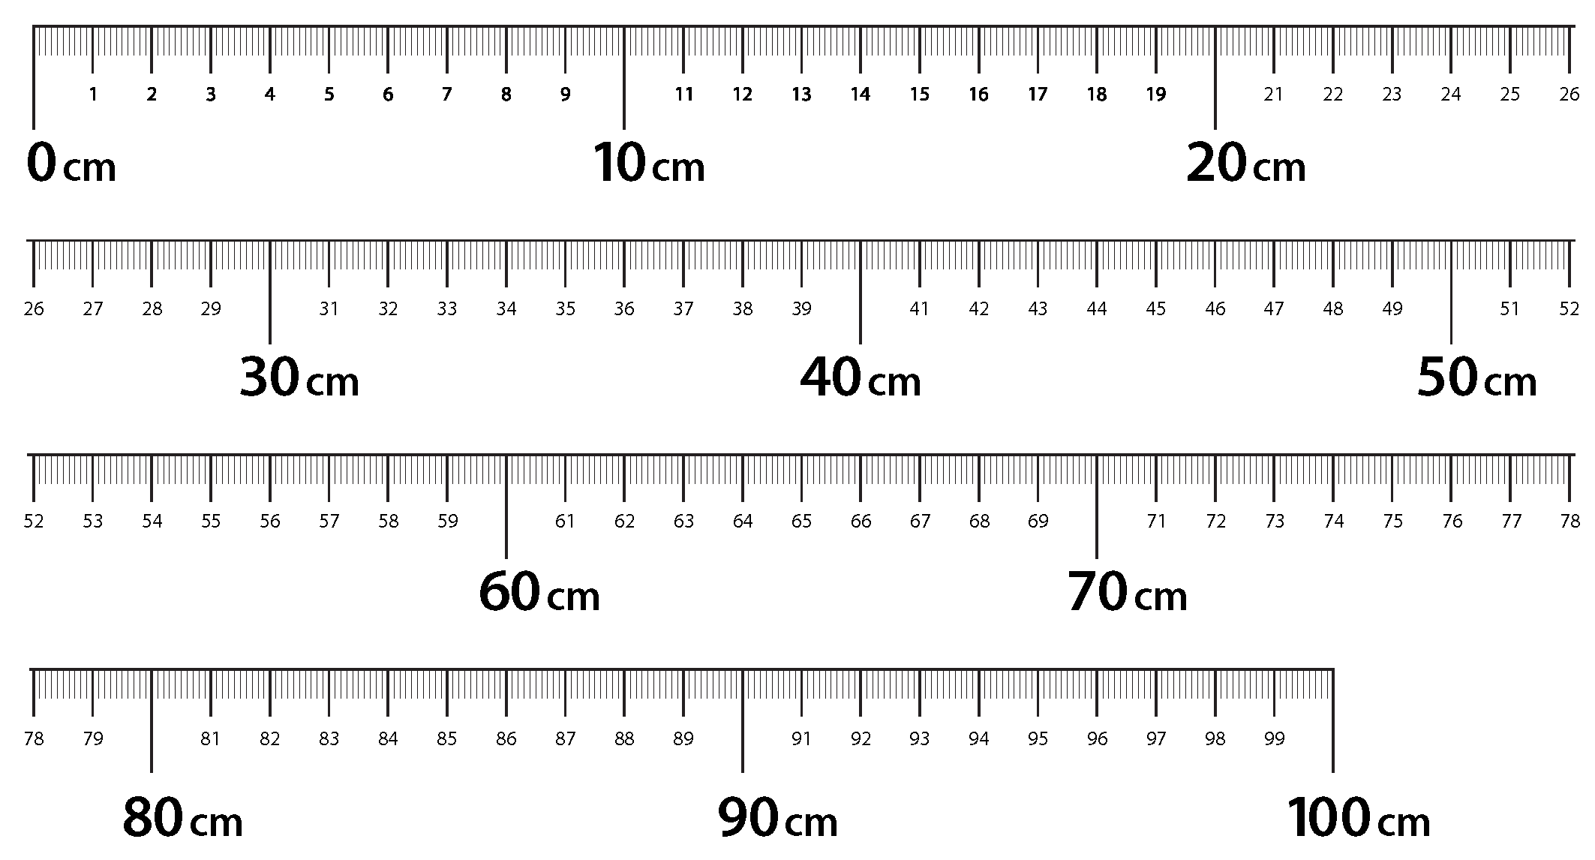

meter strip

